Week 8 exercises

Hey again :)

Today, we will spend time on three different things:

1. Working on the second portfolio

2. Doing some exercises from about model comparison

3. Talking about things that were difficult from the lectures

How to divide the time between the three is pretty much up to you :)

Below can be found exercises to do.

# Exercises on model comparison

**1. (Conceptual, Discussion)**

Explain what regularizing priors are good for, and why. Explain what happens if they are too regularizing.

**2. (Conceptual, Discussion)**

Explain what Cross Validation is good for, and why. Explain what PSIS is and why it can be useful.

**3. (Conceptual, Discussion)**

Explain in general what the Information Criteria are useful for. Explain what WAIC is (look at the equation), and what the difference is between older information criteria.

**4. (Conceptual, Discussion)**

Explain the following plot, and what the point of it is. It's also in the book.

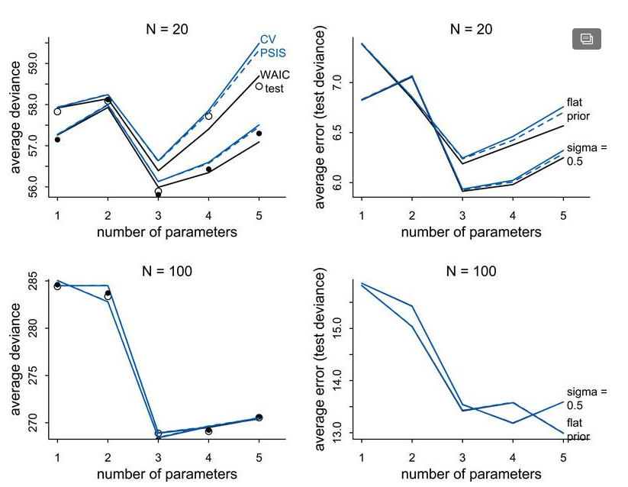

**5. (Conceptual, Discussion)**

Explain the difference between model selection and model comparison. What does it have to do with standard errors? Why does McElreath like model comparison better?

**6. (Conceptual, Discussion)**

Explain why using a t-distribution instead of a gaussian distribution to link the mean to the outcome can reduce issues with extreme values (sometimes called 'outliers').

**7. (Practical, Coding)**

Complete the following two exercises from the book. Make sure to have a laugh at these #BadStatistics *Wall Street Journal* types.

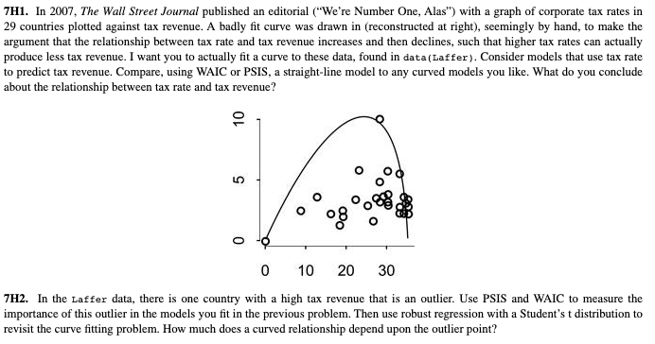

**8. (Practical, Coding)**

Do the following exercise from the book. Oh, foxes.

